**Aryaman Mishra**

**19BCE1027**

**EXPERIMENT 4**:VLANS AND INTER-VLANS(Class and Post-Lab Topology Included)

**AIM**:Implement VLAN and Inter-VLAN for same/new topology and explore Inter-VLAN.

**Topology:**

(CLASS)

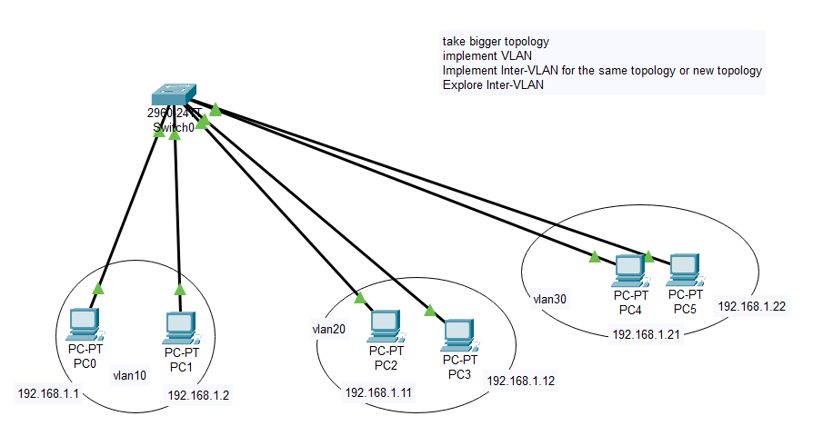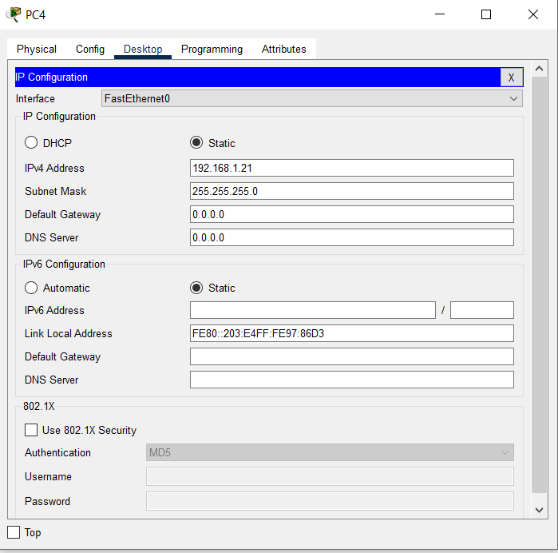

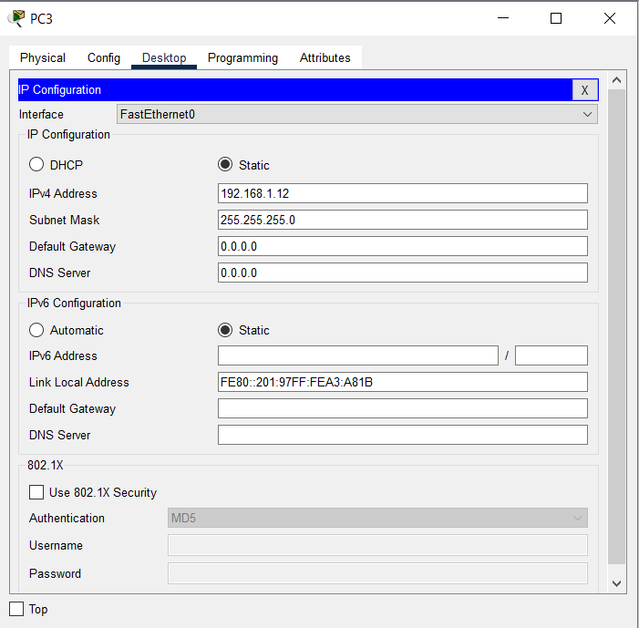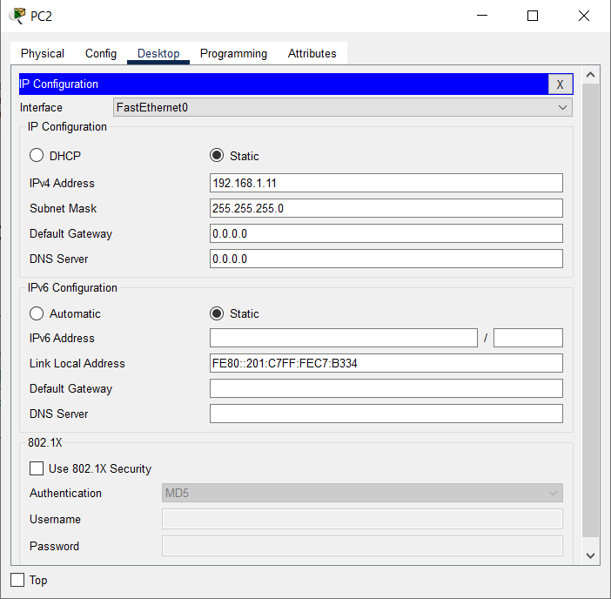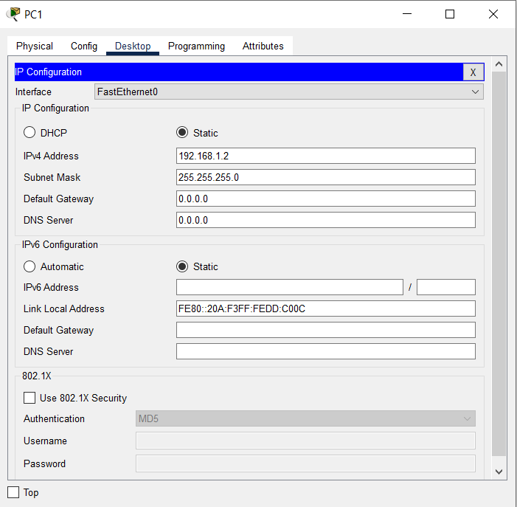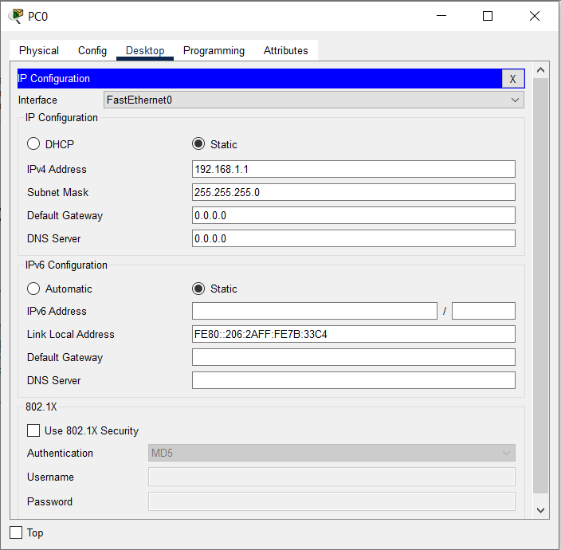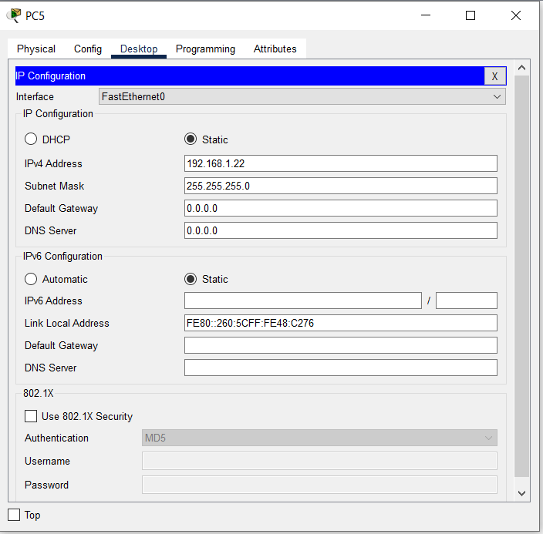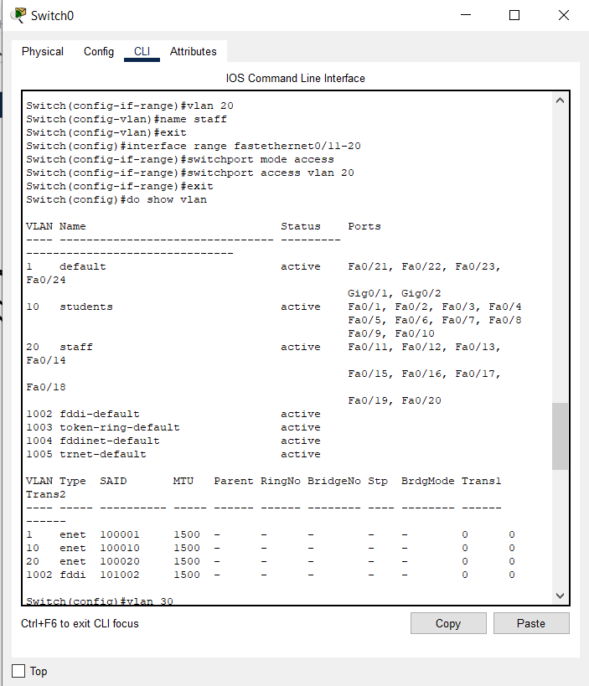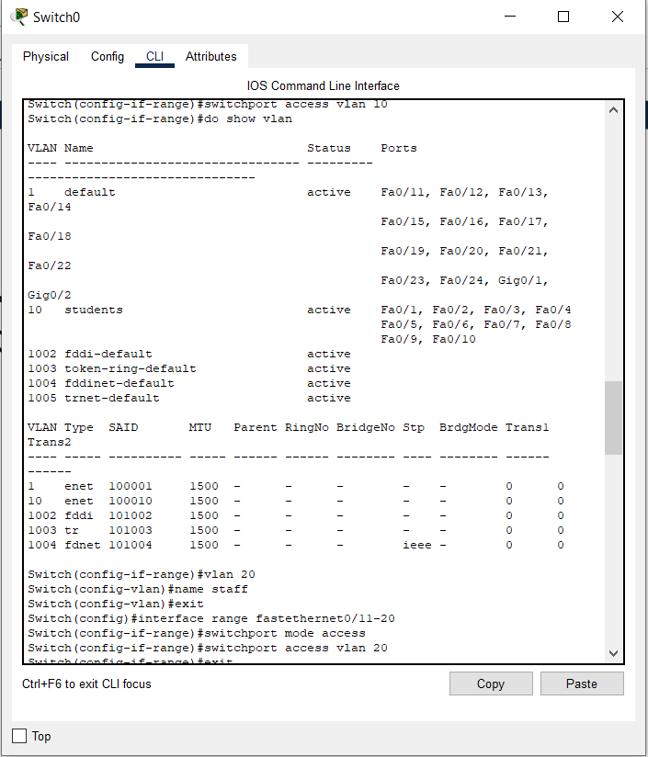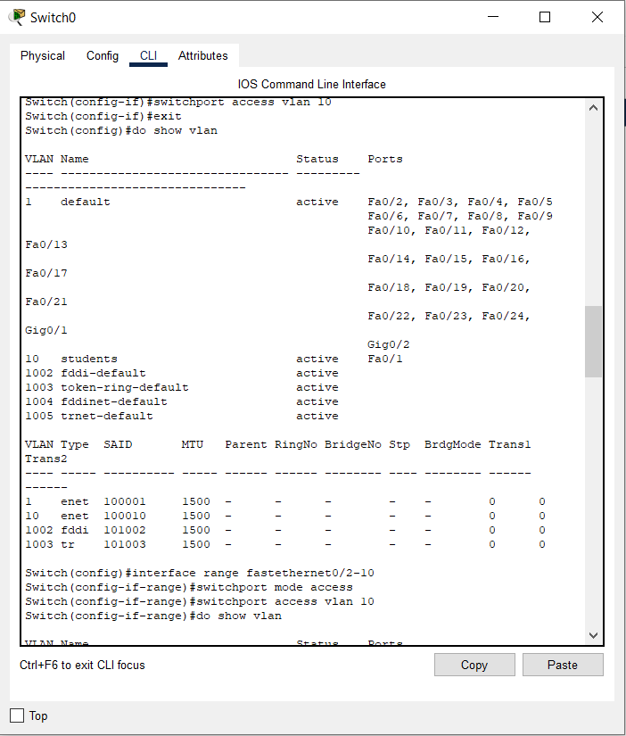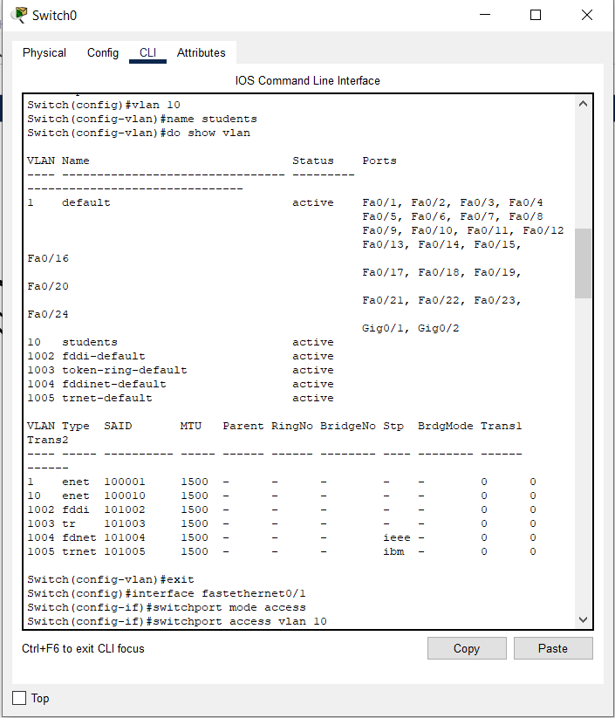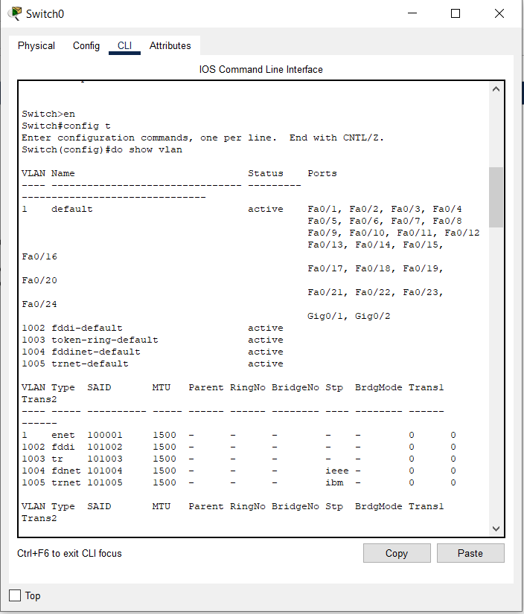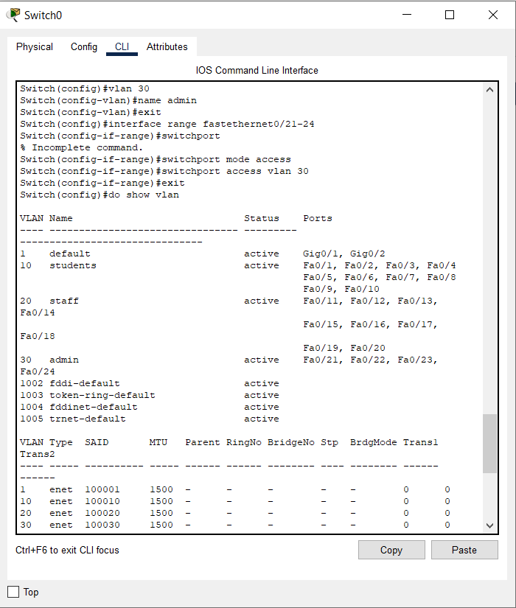

Pinging other endpoint devices

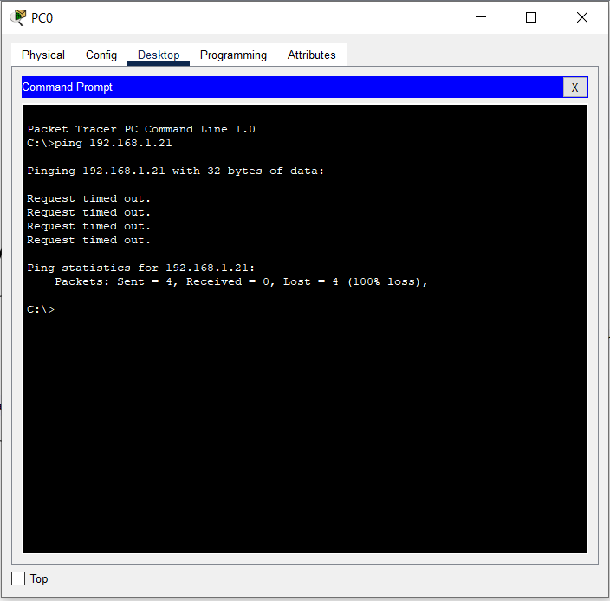

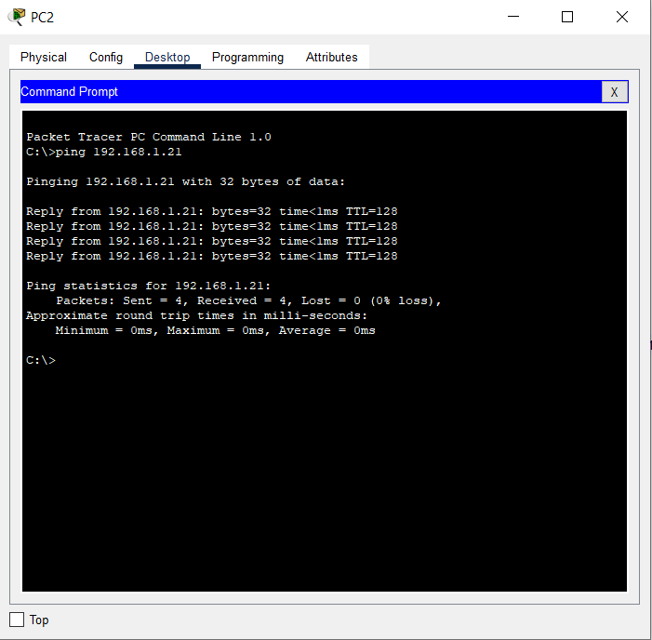

: 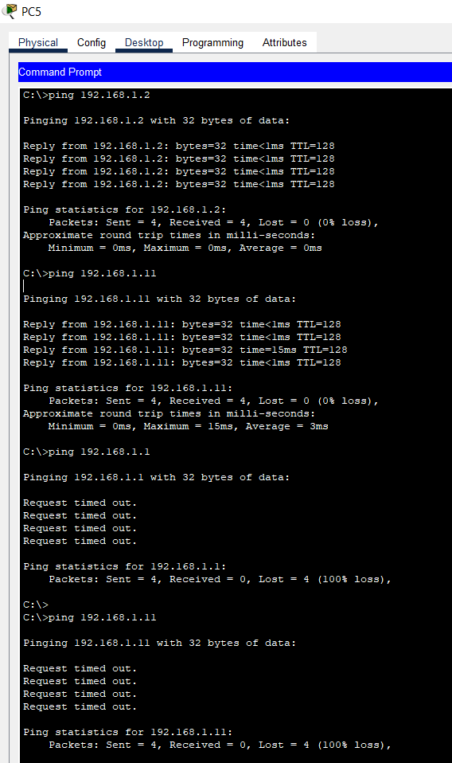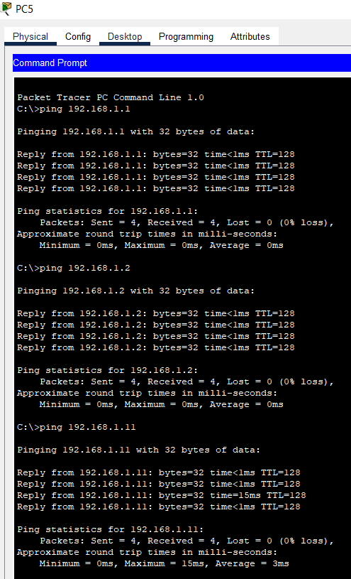

Sending Packets from one VLAN to another: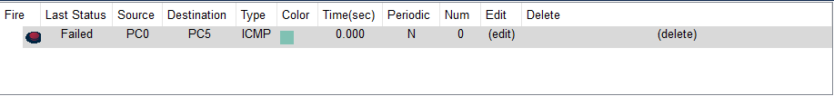

(POST-LAB)

Topo;ogy

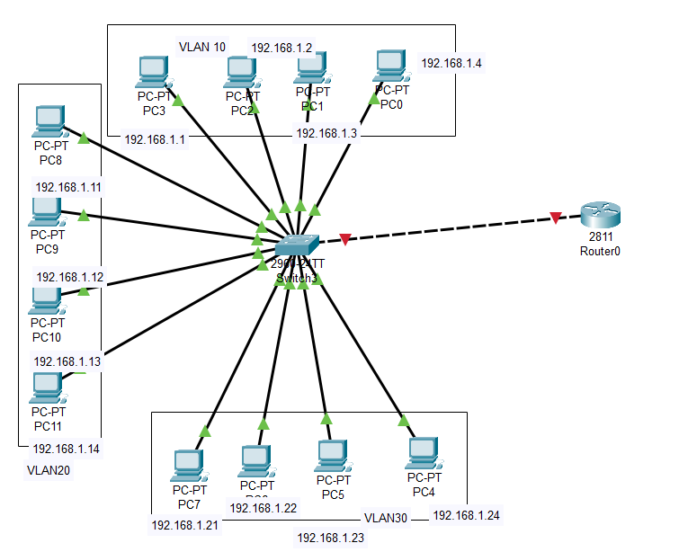

Configurations:

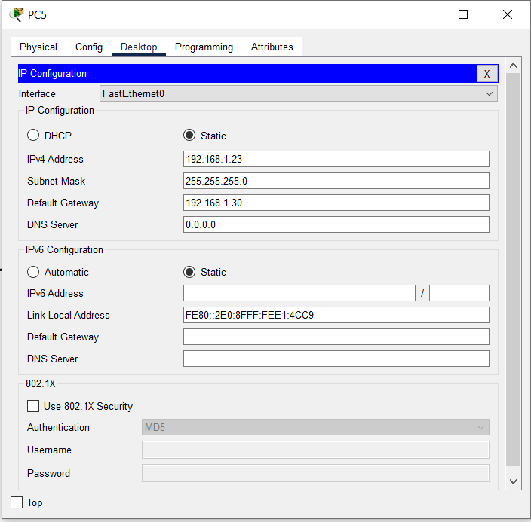

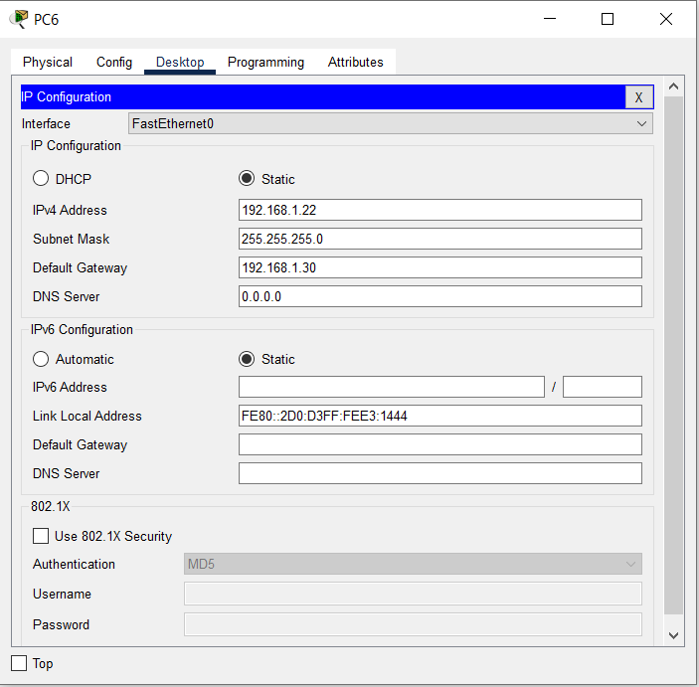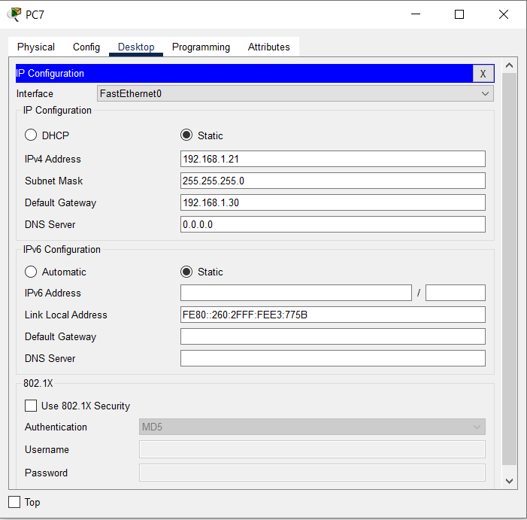

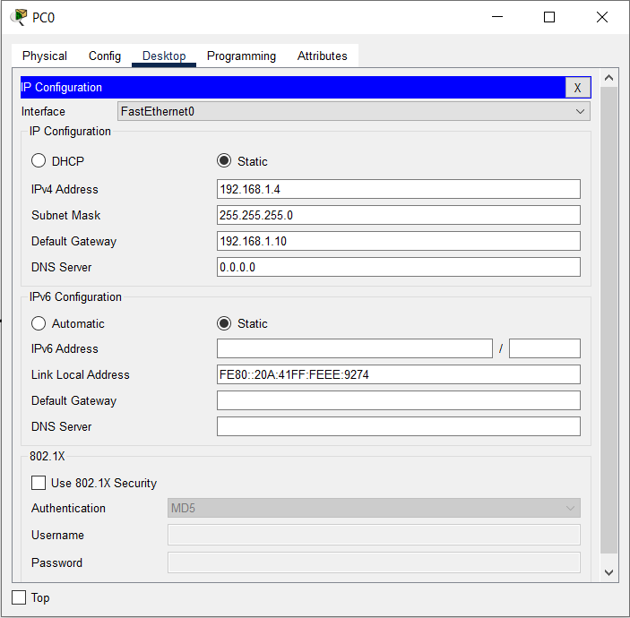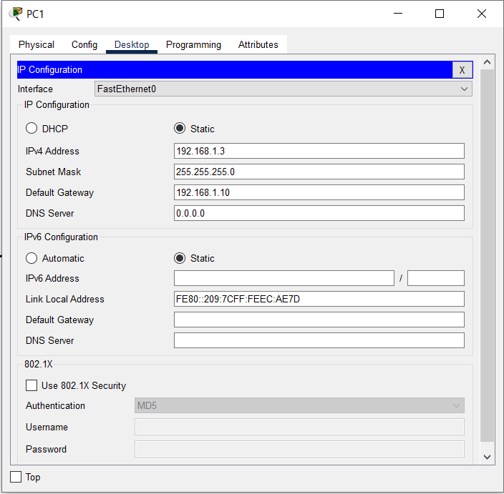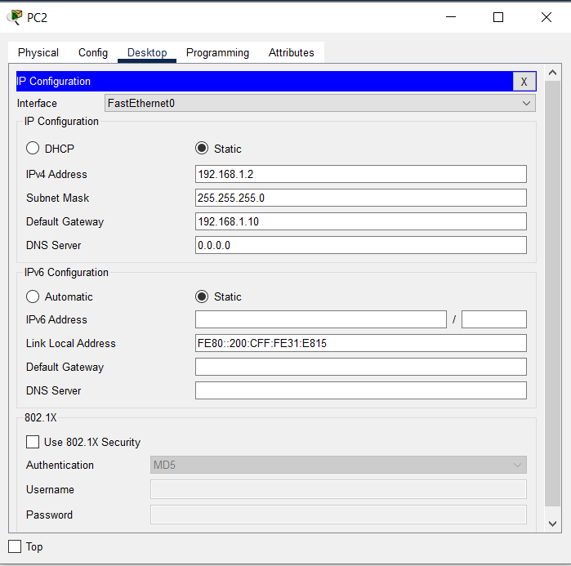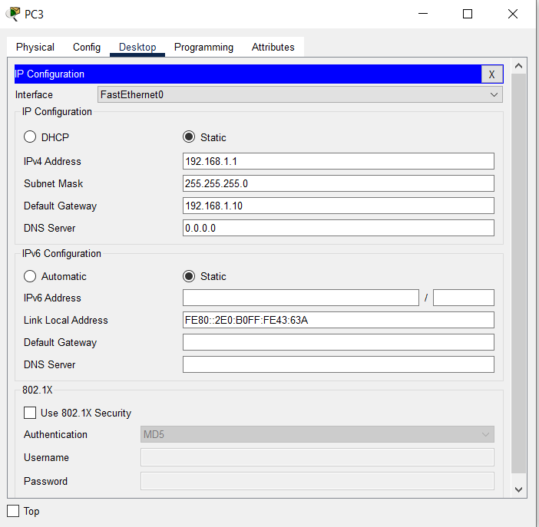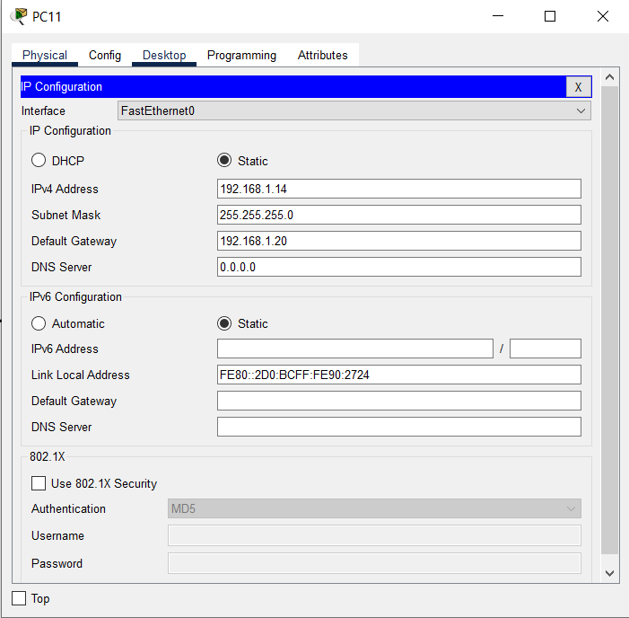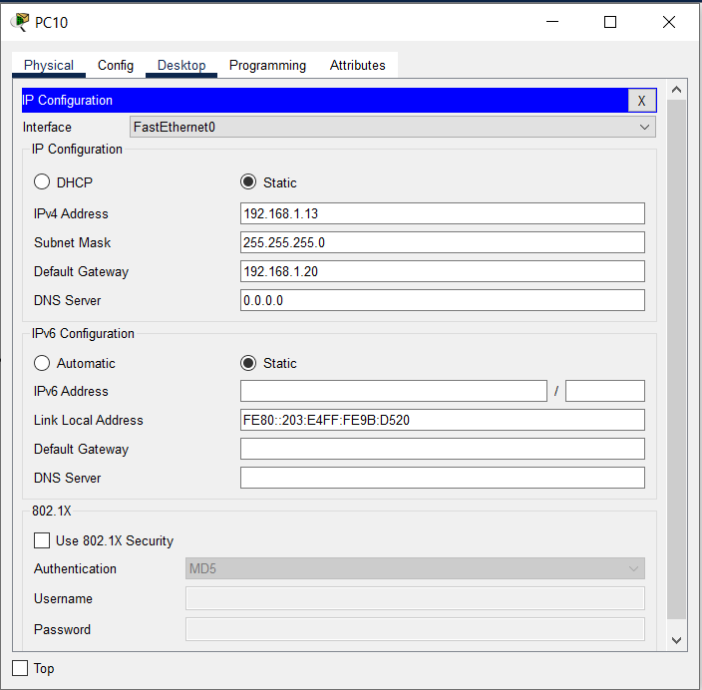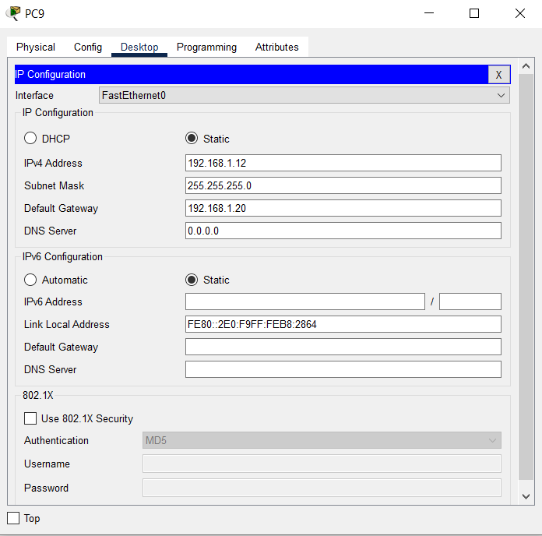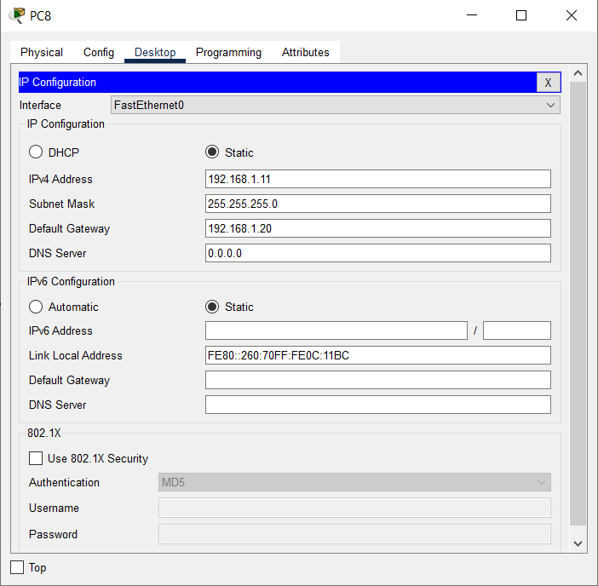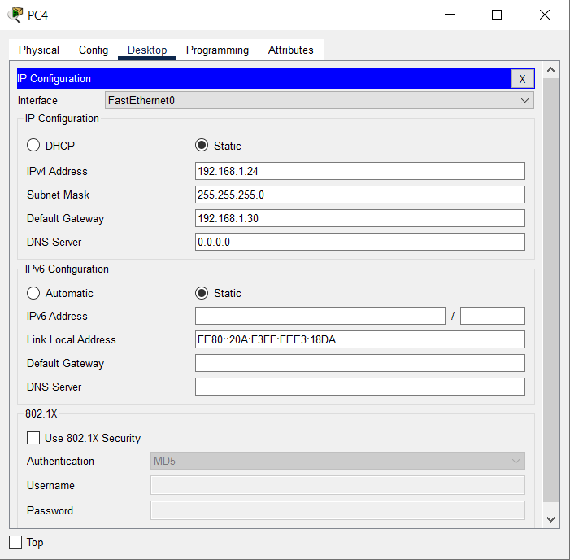 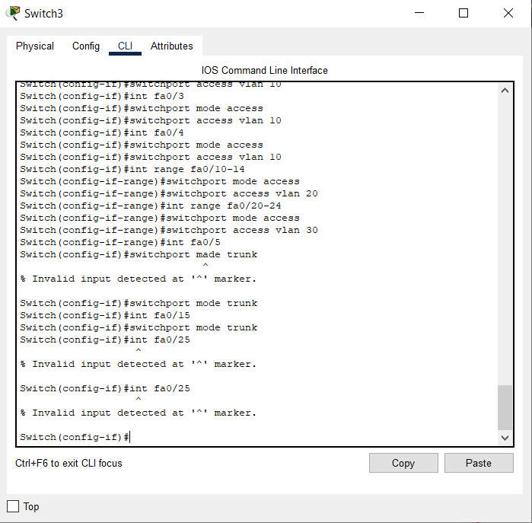

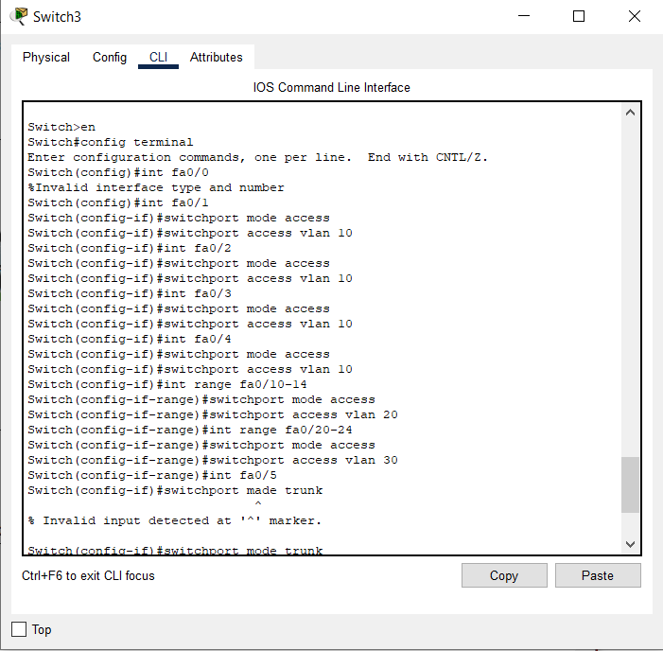

SENDING PACKETS FROM ONE DEVICES TO ANOTHER:

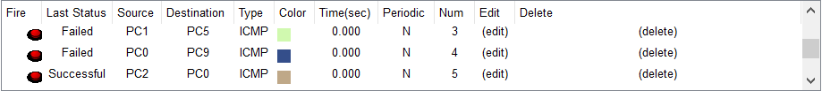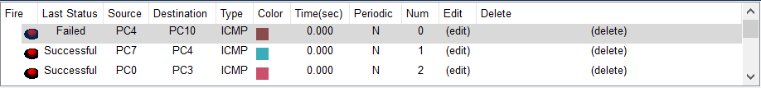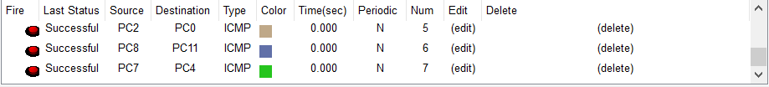

INTER-VLAN

Topology: 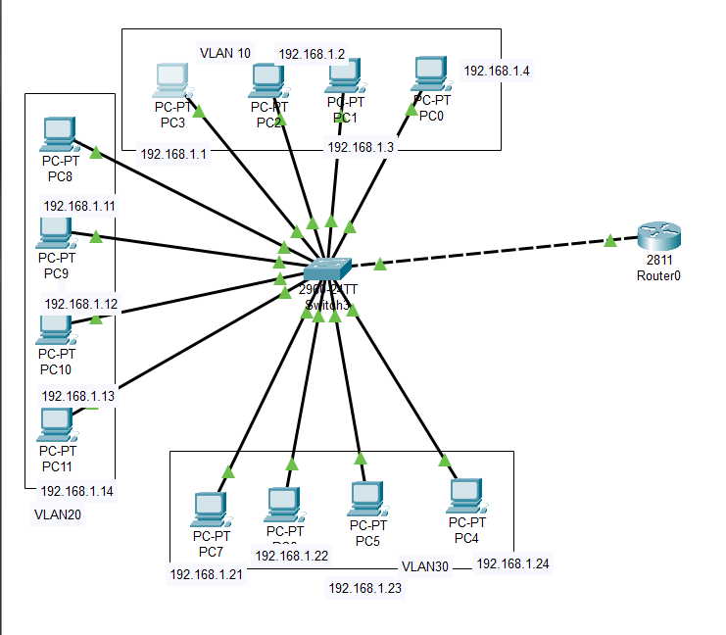

Router Configuration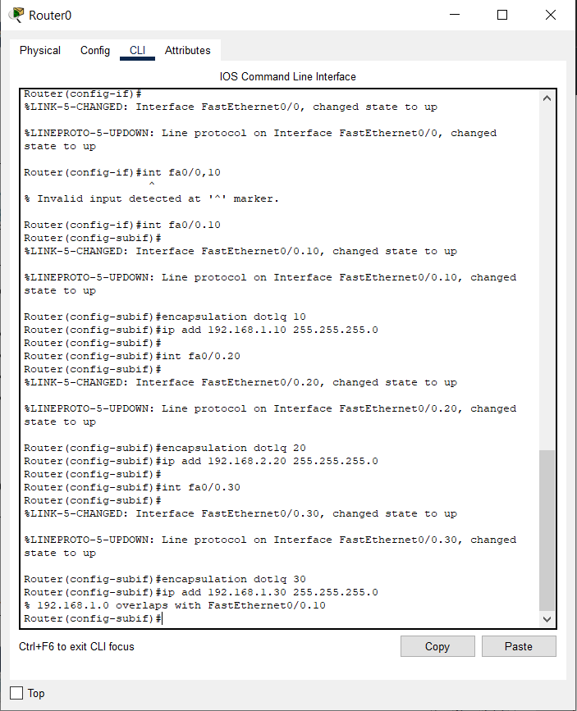:

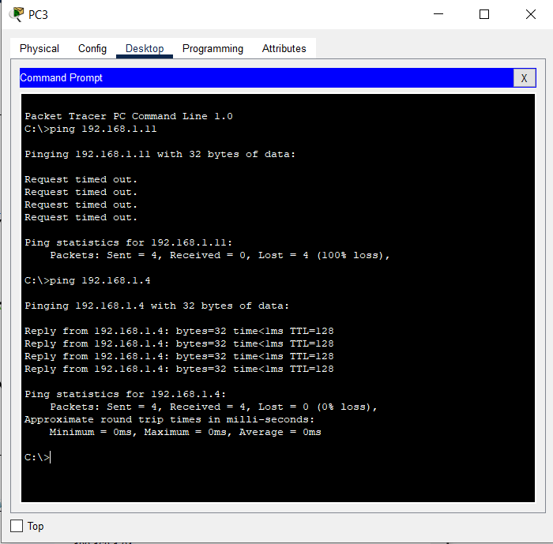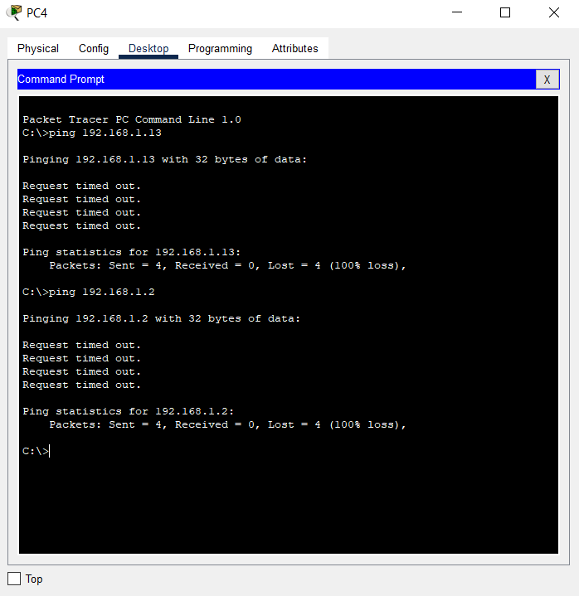

**Inference**

A Virtual LAN (**VLAN)** is simply a logical LAN, just as its name suggests. VLANs have similar characteristics with those of  physical LANs, only  that  with VLANs, you can logically group  hosts even if they are physically  located on separate LAN segments.

We treat each VLAN as a separate subnet or broadcast domain. For this reason, to move packets from one VLAN to another, we have to use a router or  a layer 3 switch.

VLANs are configured on switches by placing some interfaces into one broadcast domain and some interfaces into another.

An *access port* is  assigned to a single VLAN . These ports are configured for switch ports that connect to devices with a normal network card, for example a PC in a network.

A *trunk port* on the other hand is a port that can be connected to another switch or router. This port can carry traffic of multiple VLANs.

Test inter-VLAN connectivity.

Here we’ll test connectivity between computers in different VLANs . Don’t forget that its the router that enables  inter-VLAN routing.

Ping PC3 in VLAN  20 from PC1 in VLAN 10. If everything is well configured, then ping should work perfectly.

**Conclusion:**

VLAN and inter-VLAN has been successfully implemented.